For the purposes of this project, we looked for demographic information related to adopted and adoptable dogs in shelters within a 150-mile radius of San Antonio, between January and November 2020. Specific research questions included:

**How many animal shelters are within 150-mile radius of San Antonio?**

A total of 123 shelters were represented in this sample.

**How many dogs were in these shelters between January and November 2020?**

Between January and November 2020, a total of 7,478 dogs were in these shelters.

**Out of the total number of dogs, how many were adopted during this time? How many dogs are still adoptable as of November 2020?**

The total number of adopted dogs as of November 15, 2020 was 5,824 or approximately 78% of the total number of dogs. The total number of dogs that were still available for adoption on November 15, 2020 was 1,654 or approximately 22% of the total number of dogs.

**For the total number of dogs and adopted/adoptable comparisons in these shelters:**

* **What were the top five breeds of adopted/adoptable dogs?**

The top five adopted dog breeds: Labrador Retriever, Chihuahua, Terrier, Pit Bull Terrier, Dachshund

The top five adoptable dog breeds: Labrador Retriever, Pit Bull Terrier, Shepherd, Terrier, American Staffordshire Terrier

* **What was the gender breakdown of adopted/adoptable dogs?**

The gender breakdown of adopted dogs: 51.6% Female, 48.4% Male

The gender breakdown of adoptable dogs: 43.8% Female, 56.2% Male

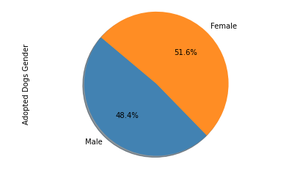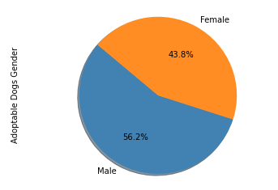

* **What were the size groupings of the adopted/adoptable dogs?**

The highest number of dogs were found to be in the small and medium categories for both the adopted and adoptable populations.

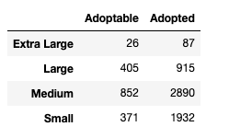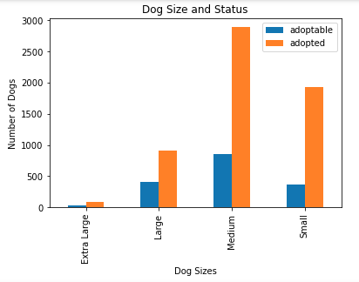

* **What were the age groupings of the adopted/adoptable dogs?**

The highest number of dogs were found to be in the young and adult categories for both the adoptable population and the baby and adult categories for the adopted population.

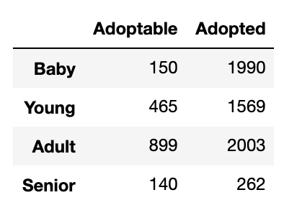 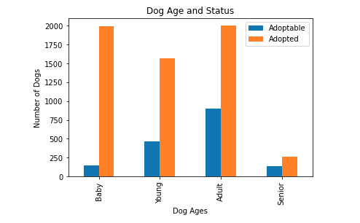

* **What percentage of the adopted/adoptable dogs were spayed/neutered?**

The adopted dogs population shows a higher percentage of dogs that were spayed/neutered (80.6%) compared to the adoptable population which show 70.4% of dogs being spayed/neutered.

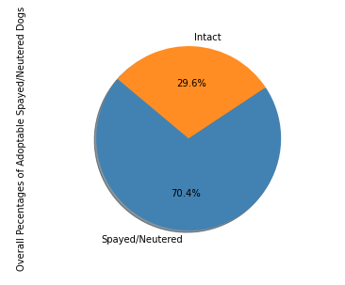 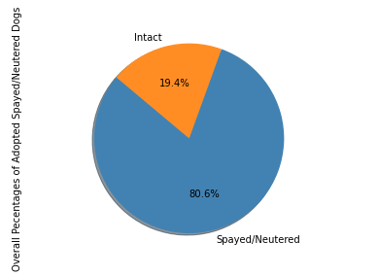

* **What percentage of the adopted/adoptable dogs were vaccinated?**

The adopted dogs population shows a higher percentage of dogs that were vaccinated (82.4%) compared to the adoptable population which show 54.2% of dogs being vaccinated.

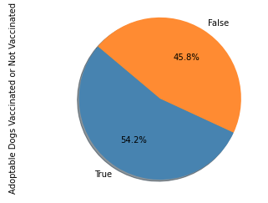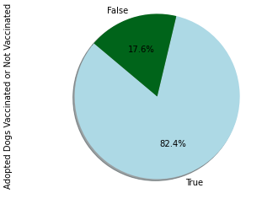

**Which shelter in the 150-mile radius has the most dogs?**

The shelter with the most dogs during this time period is the SNIPSA organization, which had 668 total dogs, representing 60 unique dog breeds, between January and November 2020. The most commonly found dog breed within this organization was the Chihuahua, with 77 dogs representing this breed.

**How do the demographics of the largest shelter compare to the overall shelter population?**

The demographics of the dogs within the SNIPSA organization and the dogs in the overall shelter population were relatively similar in terms of gender breakdown and dog sizes. The SNIPSA organization has a gender breakdown of 50.7% females and 49.3% males, while the overall shelter population has a gender breakdown of 49.9% females and 50.1% males. The most frequent size of dogs represented in SNIPSA and the overall shelter populations was the medium size dog (59.7% in SNIPSA and 50.0% overall shelter population) and both saw a similar percentage of small dogs in their respective populations (27.7% in SNIPSA and 30.8% overall shelter population).

The SNIPSA organization shows significantly higher percentages of spayed/neutered dogs (99.4%) compared to the overall shelter population (80.6%). In addition, the SNIPSA organization also has higher vaccine rates with 98.4% of dogs being vaccinated in comparison to the overall shelter population of 76.2% of dogs being vaccinated. With the populations considered in the two shelter data sets these numbers are pretty competitive. The large percentages of dogs that were spayed/neutered and vaccinated in the SNIPSA population is a reflection of the values of the organization. According to their webpage, SNIPSA is committed to providing appropriate medical interventions to all animals in their organization and holds free spay/neuter clinics in the San Antonio Community. The SNIPSA data in these may also show a recognition of the idea that dogs that have their vaccines and have been spayed or neutered are more likely to be adopted over dogs without these characteristics.

When comparing dog ages, the overall shelter population shows the highest number of dogs in the Adult age category, while the SNIPSA organization shows the highest number of dogs in the Baby and Young categories. We might be able to attribute the age of the dogs being younger in the SNIPSA organization with the demographics of the neighborhoods around it. A higher populated urban shelter will draw a wider range of customers looking for younger dogs to introduce to their current or new family.

On August 12, 2020 the *Washington Post* published an article by writer Kim Kaven titled “Dog Adoption and Sales Sore during the Pandemic”. In the article Kaven wrote: “Some rescues were reporting dozens of applications for individual dogs. Some breeders were reporting waiting lists well into 2021. Americans kept trying to fill voids with canine companions, either because they were stuck working from home with children who needed something to do, or had no work and lots of free time, or felt lonely with no way to socialize.” This is a common trend in pet shelters across the nation. One fear shelters are facing right now, is what those people will do once they start going back to school and work after the pandemic, a fear of mass abandonment is in the back of their minds.

**Final Thoughts**

It is important to note that all of the data shown here was collected during a global pandemic. It is impossible to generalize the presented results across the state of Texas, or even to a time that is outside of a pandemic.